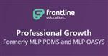**How to Complete Self Reflection on my learning Plan**

1. Log in to your My Learning Plan.
2. Prospect website- Teacher/Staff Tab/ My Learning Plan
3. Click on self reflection

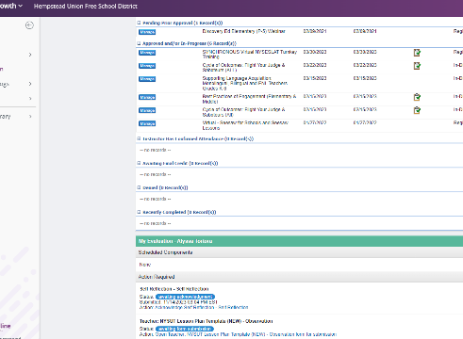

1. Complete the questions.

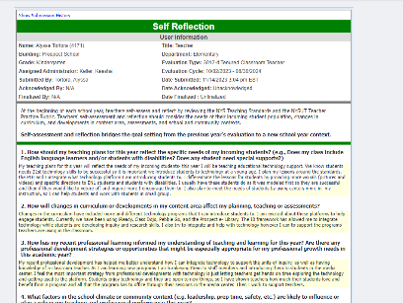

5. Press submit at the bottom. Submit to the administrator.

Mrs. Eason/Ms. Keller

6. Once it has been reviewed you can go back and press acknowledge.

